**Refer to PL part inputs**.

FPGA SPECIFICATIONS

**Lior Yosef**

Date 22-01-2024

2024

Contents

ON COMMAND 2

STATUS MESSAGAE 2

ENABLE POWER SUPPLIES 4

STATUS MESSAGAE 6

Voltage RMS Calculations 8

Current RMS Calculations 9

I_sns 9

Current Calculations 10

Current offset measurement 11

Current offset Calculations 12

**FAN Control** 13

SHUTDOWN_OUT_FPGA 13

ESHUTDOWN_OUT_FPGA 13

RESET_OUT_FPGA 13

VCC_12V_REDUNDANT POWER DOWN ALARM 14

POD STATUS FPGA(LOW) CHECK USING LAMP STATUS 15

POD STATUS FPGA(HIGH) CHECK USING LAMP STATUS 16

# ON COMMAND

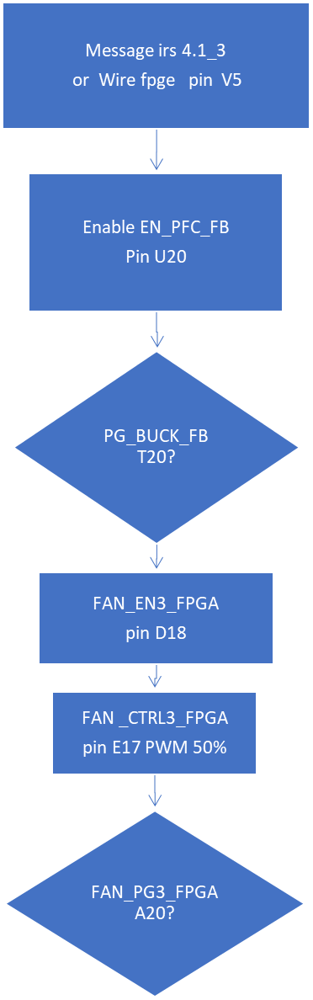

refer to  **FAN Control**

# STATUS MESSAGAE

FAN_EN2_FPGA

FAN_EN1_FPGA

YES

## POD STATUS FPGA(LOW) CHECK USING LAMP STATUS

## [POD STATUS FPGA(HIGH) CHECK USING LAMP STATUS](#_POD_STATUS_FPGA(HIGH))

NO

Output 1KHZ 50%

FB_PG1   
FB_PG2

FB_PG3

F

CONTINUE TO ENABLE POWER SUPPLIES

CONTINUE TO ENABLE FAN

# ENABLE POWER SUPPLIES

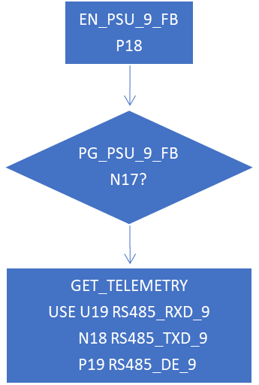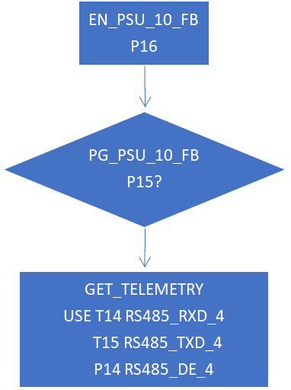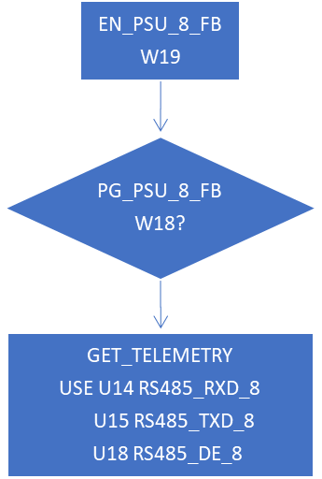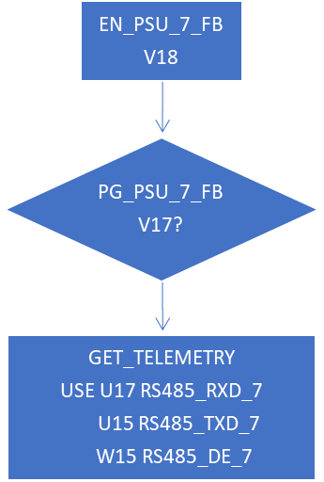

BUCK

USE V13 RS485_RXD_3

V12 RS485_TXD_3

W13 RS485_DE_3

**1msec after**

**All PG are ON:**

CCTCH_INH_FPGA G19

ECTCH_INH_FPGA H20

Go ON

# STATUS MESSAGAE

POD_STATUS_FPGA G17

Refer 3.1.6

LAMP_STATUS_FPGA J15

INPUT: if POD_STATUS_FPGA is HIGH

LAMP_STATUS_FPGA should be HIGH else 🡪 ERROR

# Voltage RMS Calculations

result 🡪 Vsns_PH1, Vsns_PH2, Vsns_PH3

Sample frequency = 10kHz (AC FREQUENCY=400Hz, samples number=25, minimum samples number is 20)

CODE:

for (I=0; I<25; I++)

If (result>2048) {

$$new result=\frac{{\left(\frac{result-2048}{6.72*{10}^{-3}*4096/3}\right)}^{2}}{25}$$

sum+=new result

}

else {

$$new result=\frac{{\left(\frac{2048-result}{6.72*{10}^{-3}*4096/3}\right)}^{2}}{25}$$

sum+=new result

}

Rms input voltage = $\sqrt{sum}$

**The result unit is VOLT.**

**1 - LSB = 0.109 Volt**

**==================================**

# Current RMS Calculations

# I_sns

# Current Calculations

Offset🡪 every input has its offset calculated. see **Current offset measurement**

result 🡪 PH1_I_sns, PH2_I_sns, PH3_I_sns, DC_PWR_I_sns

N 🡪 samples number

Sample frequency = 10kHz (AC FREQUENCY=400Hz, minimum samples number is 20)

CODE:

for (I=0;I<25;I++)

If (result>offset) {

$$new result={\left(\frac{result-offset}{50*{10}^{-3}*4096/3}\right)}^{2}/25$$

sum+=new result

}

else {

$$new result={\left(\frac{offset-result}{50*{10}^{-3}*4096/3}\right)}^{2}/25$$ sum+=new result

}

Rms input current = $\sqrt{sum}$

**The result unit is Amper.**

**1 - LSB = 0.0147Amper**

# Current offset measurement

# 

Frequency 1kHz

## Current offset Calculations

Offset🡪 every input has its offset just as it read

result 🡪 PH1_ZCR_sns, PH2_ZCR_sns, PH3_ZCR_sns, DC_PWR_ZCR_sns

no calculation is needed.

CODE:

result offset = result (the raw data)

# FAN Control

There are three Fans. Each Fan need enable signal FAN_EN1, FAN_EN2, FAN_EN3

FAN speed is controlled by FAN_CTRL FAN_CTRL1.FAN_CTRL2, FAN_CTRL3

FAN_CTRL is square wave at 1Khz with duty cycle TBD (let’s start with 50%)

The FANS actual SPEED IS feedback by hall effect signal FAN_HAAL1_FPGA, FAN_HALL2_FPGA, FAN_HALL3_FPGA.

The hall1,2,3 frequency is equal to the FAN speed, and it is measure and compare to a fix value which is TBD.

In case the speed (hall frequency) is out of the desired operation range the CTRL duty cycle is increased or decreased in purpose we need to increase or decrease the FAN speed.

Each Fan has a different speed.

All values will be declared after FAN integration.

SHUTDOWN_OUT_FPGA G15

Refer to 3.1.5.2 for shutdown when system power of (named power down)

Refer to 3.2.10.2.1 to create shut down in over voltage for input voltage.

Refer to 3.2.10.5 to create shut down in over temperature.

ESHUTDOWN_OUT_FPGA K14

Refer to 3.2.10.2 for the case of outputs over voltage.

RESET_OUT_FPGA H15   
 refer to 3.1.5.1 System Reset (“short” reset)

## VCC_12V_REDUNDANT POWER DOWN ALARM

100Hz sampling

NO

YES

NO

YES

## POD STATUS FPGA(LOW) CHECK USING LAMP STATUS

NO

## [POD STATUS FPGA(HIGH) CHECK USING LAMP STATUS](#_POD_STATUS_FPGA(HIGH)_1)

NO

YES

YES

## POD STATUS FPGA(HIGH) CHECK USING LAMP STATUS

CHECK 3 TIMES